Blunt Thoracic Aortic Injury (BTAI) Aortic Trauma Foundation Prospective Registry

Demographics:

1. Age (years): _____
2. Gender: ____Male ____Female
3. Date of Injury: (Month/Date/Year)
4. Time of admission: ______
4. Country of placement: ________

5. Known Comorbidities (select all that apply):

___ Coronary Artery Disease ___ Peripheral Vascular Disease ___ Hypertension
___ Carotid artery disease ___ Dialysis dependent renal failure ___ Smoker
___ Prior stroke ___ Angina ___Atrial Fibrillation
____Congestive Heart Failure ____Known prior aortic aneurysm
___Known prior aortic dissection ____ Cancer (Type: __________)
___ Known connective tissue disease (Type: ________)
___ Other pertinent: (Write in: __________)

6. Known pre-injury medications (select all that apply):

___ Aspirin ___ Non-aspirin anti-platelet ___ Beta-Blocker
____Calcium Channel Blocker ___ Statin ___ Warfarin
____Other anticoagulant: (Write In: _______)

7. Known pre-injury prior surgeries

___ Prior carotid endarterectomy
___ Prior cardiac revascularization
____ Percutaneous angioplasty
____ Percutaneous stenting
____ Coronary artery bypass grafting
____ Left internal mammary utilization for coronary bypass
____ Right internal mammary utilization for coronary bypass
___ Prior median sternnotomy
___ Prior thoracotomy (non-sternotomy)
___ Prior percutaneous coronary intervention
___ Prior aortic surgery
___ Prior peripheral artery open surgery
___ Prior peripheral artery endovascular surgery
____Prior Abdominal exploration / surgery
____Prior cardiac valve surgery (Type: _________)

8. Mechanism (check most appropriate):
____ Motor vehicle collision
____ Motorcycle accident
____ Auto vs. Pedestrian
____ Fall
____ Work-related accident
____ Other: Write in (_________)

9. Admission Physiology / Exam:

Systolic blood pressure: ________ mm Hg
Admission Mean Arterial blood pressure (MAP): ________mm Hg_
Heart Rate: _________
Glasgow Coma Score: _________
Temperature: _______ Celsius

10. Physical exam findings (select all that apply):

____ Thoracic seat belt or steering wheel sign ____ Other thoracic wall contusion
____ Flail chest ____ Chest pain
____ Chest wall hematoma

11. Initial trauma plain radiography (CXR) findings on admission (select all that apply):

____ Widenened mediastinum
____ Left hemothorax
____ Right hemothorax
____ Left pneumothorax
____ Right pneumothorax
____ Clavicular fracture
____ Rib fractures (Side : ____ number:____)
____ Sternal fracture
____ Pneumomediastinum
____ Apical cap
____ Scapula fracture
____ Deviated trachea or nasogastric tube
____ Loss of anterior-posterior window

12. Admission labs (if obtained at admission):

Lactate : _____ mmol/L
Creatinine: ______ mg / dL
Hemoglobin _____ mg / dL
Platelet Count: ______
Partial thromboplastin time (PTT): ____ secs
Prothrombin time (PT): ____ secs
International Normalized Ratio: _____
pH _______
Base Deficit: -/+________

13. Injury Scoring:
Injury Severity Score (ISS): ______
Abbreviated Injury Score (AIS) - Head ______
Abbreviated Injury Score (AIS) – Chest ______
Abbreviated Injury Score (AIS) - Abdomen ______
Abbreviated Injury Score (AIS) – Extremities ______

14. Other specific associated injuries (select all that apply):
___ Intracranial hemorrhage or contusion
___ Facial fractures
___ Cervical Spinal fracture:
___ Thoracic Spinal fracture
___ Lumbar spinal fracture
___ Sacral spinal fracture
___ Liver injury (AAST Grade ___ 1 ___ 2 ___ 3 ___ 4)
___ Splenic injury (AAST Grade ___ 1 ___ 2 ___ 3 ___ 4)
___ Renal Injury (AAST Grade ___ 1 ___ 2 ___ 3 ___ 4)
___ Bladder injury
___ Pancreatic Injury (AAST Grade ___ 1 ___ 2 ___ 3 ___ 4)
___ Hollow viscus injury ( ___ Esophageal ___ Gastric ___ Small bowel ___ Large bowel ___ Rectal)
___ Other major vascular injury (Location / type: ______)
___ Pelvic fracture (Type: ________)
___ Long bone fracture (Location: _____ Type: _______)

15. BTAI Diagnosis / Imaging data – Modality utilized to diagnose injury (Check MOST APPROPRIATE):
_____ Computed tomographic angiography (CTA)
_____ Magnetic Resonance angiography (MRA)
_____ Traditional angiography (digital subtraction)
_____ Transthoracic echocardiogram (TTE)
_____ Transesophageal echocardiogram (TEE)
_____ Intravascular Ultrasoound

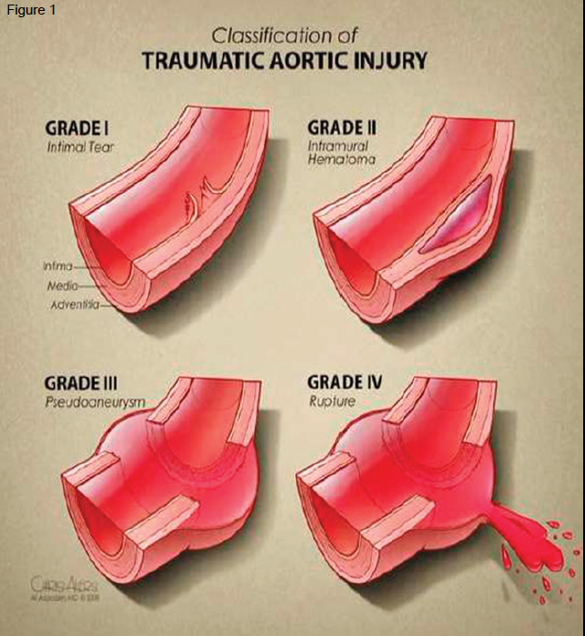
16. BTAI Grade

_____ Grade I

Length = ______ millimeters
(Length measured along greater curvature)
Maximum lesion diameter = _____ mm
Location:
___ Lesser curvature
___ Greater curvature
Distance from left subclavian artery ___ mm

_____ Grade II
Length = _______ mms
(Length measured along greater curvature)
Maximum lesion diameter = _____ mm
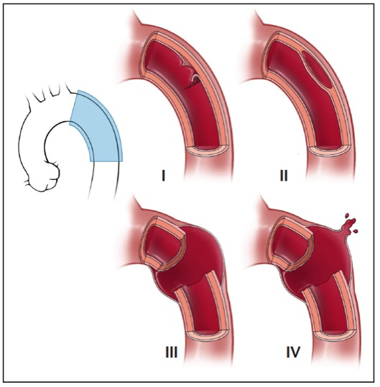
Location:
___ Lesser curvature
___ Greater curvature
Distance from left subclavian artery ___ mm

_____ Grade III
% circumference (estimated)
____ < 25%
____ 26% - 50%
____ 51% - 75%
____ > 75%
Length = ______ mm
(Length measured along greater curvature)
Maximum lesion diameter = _____ mm
Location:
___ Lesser curvature
___ Greater curvature
Distance from left subclavian artery ___ mm

_____ Grade IV
Length = ______ mm
(Length measured along greater curvature)
Maximum lesion diameter = _____ mm
Location:
___ Lesser curvature
___ Greater curvature
Distance from left subclavian artery ___ mm

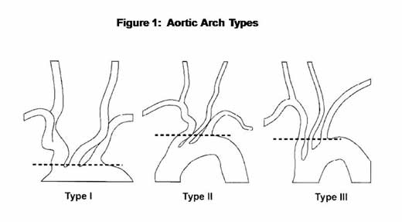
17. Aortic Arch type:

___ Type I
___ Type II
___ Type III

18. Bovine arch anatomy:
___ Yes ____ No

19. Intact and complete circle of Willis visualized?
____ Yes
____ No
____ Not applicable / Not imaged

20. Normal aortic diameter immediately above injury (cm): ____ mm

21. Normal aortic diameter immediately below injury (cm): ____ mm

22. Associated chest CT (besides initial plain CXR) findings (check all that apply):

____ Rib fractures (number:____)
____ Sternal fracture
____ Pneumomediastinum
____ Pericardial effusion or blood
_____ Pseudocoarcation
_____ Associated mediastinal hematoma with any evidence of compression or mass effect
Maximum depth of mediastinal hematoma identified: ____ cc
_____ Associated left hemothorax
Estimated volume of left hemothorax = ______ cc
(Using following formula)

CT estimate of volume of hemothorax on CT:
ESTIMATE = V (in cc) = d² X L
(d = greatest depth of hemothorax; from chest wall to lung at right angle on any one CT image, in cms)(L = craniocaudal length, in cms) (number of slices X cm thickness of CT cuts)

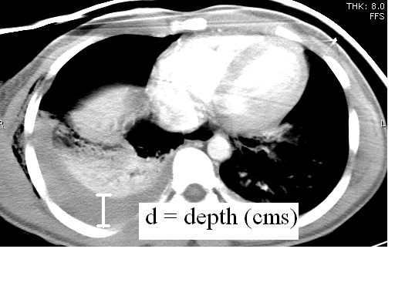

23. Medical management with blood pressure impulse controlled during INITIAL period of BTAI management: ____ Yes ____ No
Type: ____ Continuous titrated infusion of antihypertensive
____ Intermittent administration of bolus antihypertensive
Agent utilized: ___ Beta blocker ____ Calcium Chanel blocker ___ Other: _________
Goal therapy: ___ To target Systolic blood pressure ___ To target Mean arterial pressure
Goal measurement: ____ mm Hg
Goal attained: ___ Yes ___ No ___ Unknown

24. DEFINITIVE Treatment of BTAI (check ALL that apply):

_____ Medical Management alone (blood pressure control)
Type: ____ Continuous titrated infusion of antihypertensive
____ Intermittent administration of bolus antihypertensive
Agent utilized: ___ Beta blocker ____ Calcium Chanel blocker ___ Other: _________
Goal therapy: ___ To target Systolic blood pressure ___ To target Mean arterial pressure
Goal measurement: ____ mm Hg
Goal attained: ___ Yes ___ No ___ Unknown

_____ Open surgical repair
Case posting type: ___ Emergent ___ Urgent ___ Elective
Primary pecialty of primary surgeon / internventionalist:
____ Cardiac surgery ____ Vascular Surgery ___ Intervnetional radiology
____ Trauma Surgery ____ Cardiology
Date of repair: (Month/date/year): ______
Time of repair: ________
Actual time from admission to repair: ______ hours
EBL: ____ cc
Intra-operative crystalloid: ____ cc
Intra-operative PRBC: _____ units
Total procedure time: _______ mins
Left heart bypass utilized? ___ Yes ___ No
Type of cannulation utilized: (Write in): ______________
Hypothermia utilized? ___ Yes ___ No
___ Active hypothermia ___Passive permissive hypothermia
___ Goal temperature utilized: ____ Celsius
Spinal cerebrospinal fluid drain place before procedure? ___ Yes ___ No
Location of proximal aortic clamp:
____ Proximal to left subclavian artery
____ Distal to left subclavian artery
Graft type utilized: (Write in: ___________)
Graft size utilized: (Write in: ___________)

Intra-operative complications – Open
____ Iatrogenic lung injury
____ Lesion rupture

______ Endovascular repair (TEVAR)
Case posting type: ___ Emergent ___ Urgent ___ Elective
Primary specialty of primary surgeon / internventionalist:
____ Cardiac surgery ____ Vascular Surgery ___ Intervnetional radiology
____ Trauma Surgery ____ Cardiology
Date of repair: (Month/date/year): ______
Time of repair: ________
Actual time from admission to repair: ______ hours
Anesthesia: ___ General ___ Local/regional +/- sedation
Iodinated contrast utilized: ____ cc
EBL: ____ cc
Intra-operative crystalloid: ____ cc
Intra-operative PRBC: _____ units
Total procedure time: _______ mins
Total fluoroscopy time: _____ mins
IVUS utilized: ____ Yes ____ No
TEE utilized: ____ Yes ____ No
Device access side:
____ Right, Sheath / device diameter size: ____ French
____ Left, Sheath / device diameter size: ____ French
Ultrasound access guidance utilized: ___ Yes ___ No
Deployment technical success: ___ Yes ___ No
Initial percutaneous access: ___ Yes ___ No
Conversion to open required? ___ Yes ___ No
Initial open access: ____ Yes ____ No
Prosthetic conduit utilized for access? ___ Yes ___ No
Device access artery injury? ___ Yes ___ No
Access closure: ___ Percutaneous device
___ Proglide
___ Perclose
___ Other (Write in)
___ Open arterial closure without patch angioplasty
___ Open arterial closure with patch angioplasty
Device utilized:
Manufacturer: _________________________________
Diameter - proximal : __________________________________
Diameter - distal: :__________________________________
Length) : __________________________________
Left SCA covered? (check one): _____ Yes _____ No
Additional endovascular modality required to maintain left SCA perfusion ____ Yes ____ No
____ Snorkel / Chimney
____ Branched graft
____ Laser fenestration with graft placement
____ other (please specify:________)
Spinal cerebrospinal fluid drain place before procedure? ___ Yes ___ No
___ Initial spinal fluid pressure: ____ mm Hg
Therapeutic active hypothermia utilized intra-operatively? ___ Yes ___ No

Intraoperative complications – Endovascular
_____ Endograft malpositioning at time of initial endovascular procedure
_____ Endoleak
Type? ____ I ____ II ____ III _____ IV (see data dictionary for definitions)
_____ Failure of device delivery
_____ Failure of device deployment
_____ Device migration
_____ Device maldeployment
_____ Device malposition
_____ Lesion rupture
_____ Access complication
______ Access artery laceration
______ Access artery dissection
______ Access artery related thrombosis
______ Access artery related embolism
______ Access artery related rupture

25. Initial post-operative labs:

Lactate : _____ mmol/L
Creatinine: ______ mg / dL
Hemoglobin _____ mg / dL
Platelet Count: ______
Partial thromboplastin time (PTT): ____ secs
Prothrombin time (PT): ____ secs
International Normalized Ratio: _____
pH _______
Base Deficit: -/+________

26. Initial post-operative vital signs / evaluation / care:

Systolic blood pressure: ____ mm/Hg
Mean arterial pressure: ____ mm/Hg
Heart rate: ____ beats per minute
Initial post-operative neurologic exam with evidence of (check all that apply)
_____ Stroke – Ischemic
_____ Stroke – Hemorrhagic
_____ Paraperesis
_____ Paraplegia
Initial post-operative pressors required? ___ Yes ___ No
Agent utilized: ____ Epinephrine ___ Noriepinehrine ___ Vasopressin ___ Other(s): _____________
Spinal drainage pressure measured post-op? ___ Yes ___ No ____ Not applicable (no drainage)
Initial spinal pressure post-procedure measured: ____ mm Hg
Goal spinal drainage pressure: ____ mm Hg
Amount of CSF fluid drained first 24 hours: ______ cc
Duration of spinal drainage use: _____ days
Total CSF fluid evacuated: ________ cc

Hospital Course:

27. Other emergent procedures (check all that apply)?
_____ Craniotomy / Craniectomy
_____ Laparotomy
____ Splenectomy
____ Hepatic hemorrhage control (packing or surgical
____ Nephrectomy or surgical control renal hemorrhage
____ Large bowel repair or resection
____ Small bowel repair or resection
____ Definitive fascial closure at completion of laparotomy
____ Temporary abdominal closure at completion of laparotomy (wound vac / damage control closure)

_____ Thoracotomy / Median Sternotomy (for other than open BTAI repair)
____ Definitive thoracic closure at completion of laparotomy
____ Temporary thoracic closure at completion of laparotomy (wound vac / damage control closure)

_____ Others: (write in: __________________)

28. Total blood products first PRE-operatively:
Units packed red blood cells (PRBCs): _______
Units fresh frozen plasma (FFP): _______
Units platelets (PLTS): _______

29. Total blood products first INTRA-operatively:
Units packed red blood cells (PRBCs): _______
Units fresh frozen plasma (FFP): _______
Units platelets (PLTS): _______

30. Total blood products first 24 hours POST-operatively
Units packed red blood cells (PRBCs): _______
Units fresh frozen plasma (FFP): _______
Units platelets (PLTS): _______

31. Was REPEAT thoracic aortic imaging obtained during the initial hospitalization after initiation of treatment (Medical or surgical /endovascular)? (
Check One) _____ Yes _____ No

32. Type of imaging obtained and timing (date of admission = Hospital Day #1) :
____ Plain radiography specifically to assess graft position Hospital Day(s): _____
____ CTA Hospital Day(s): _____
____ Traditional Angiograpy Hospital Day(s): _____
____ MRA Hospital Day(s): _____

33. In-Hospital Complications (Check all that apply – refer to data dictionary for specific definitions of complications as required)

_____ Unanticipated return to OR for access site complication
_____ Unanticipated return to OR for index BTAI treatment complication
_____ Stent fracture
_____ Stent migration
_____ Procedure related aortic perforation
_____ Re-operation for bleeding attributable to aortic injury
_____ Delayed rupture
_____ Access site pseuduoaneurysm
_____ Access site persistent or delayed bleeding requiring intervention
_____ Access surgical site infection (SSI)
_____ Delayed paralysis attributable to aortic intervention (NOT as a direct result of spinal cord injury due to trauma)
_____ Delayed Ischemic stroke
_____ Delayed Hemorrhagic Stroke
_____ Confirmed vocal cord deficit
_____ Acute Renal Failure (serum creatinine > 2.0 mg/dL)
_____ Deep Vein Thrombosis
_____ Pulmonary Embolism
_____ Catheter-associated Urinary Tract Infection (UTI)
_____ Blood Stream Infection (BSI)
_____ Central line associated blood stream infection (CLABSI)
_____ Intestinal Ischemia
_____ Mechanical Ventilation via endotracheal tube > 48 hours required
_____ Non-invasive ventilation > 48 hours required
_____ Need for tracheostomy for prolonged ventilation
_____ Dysrythmia other than sinus tachycardia
_____ Leg ischemia / emboli
_____ Arm ischemia / emboli
_____ Spinal ischemia
____ Time to symptoms: _____ hrs
____ Permanent deficit: ___ Yes ___ No
_____ Myocardial infarction
_____ Leg compartment syndrome
_____ Surgical Site Infection
_____ Hospital Acquired Pneumonia
_____ Ventilator Associated Pneumonia
_____ Acute Lung Injury / Acute Respiratory Distress Syndrome
_____ Sepsis

34. Need for delayed aortic intervention or re-intervention DURING INITIAL HOSPITALIZATION (check all that apply):

____ Treatment required for FAILURE of medical management
Type of treatment required (check most appropriate): _____ TEVAR _____ Open repair
____ Need for re-intervention after TEVAR
Type of re-intervention (check most appropriate): _____ Endovascular ____Open
____ Need for re-intervention after Open Repair
Type of re-intervention (check most appropriate): _____ Endovascular ____Open

35. Other type of re-interventions required:

___ Access-related complication treatment
___ Delayed placement of spinal drain for plegia / paralysis
___ Return to operating room for issue related to index BTAI procedure

Intensive Care Unit Length of Stay (ICU LOS) = _______ days
Hospital Length of Stay: _______ days
Ventilator Days: _______ days

36. IN HOSPITAL MORTALITY

_____ In-hospital Mortality
_____ 30 day mortality

_____ Aortic related in hospital mortality

____ Death directly related to initial aortic injury (ex. rupture)

____ Death directly related to complication specifically of aortic treatment (ex. Procedure-related aortic
perforation, catastrophic stroke related to intervention)

If Aortic-related mortality, did it occur prior to opportunity for endovascular or open surgical intervention?
(Check one): ____ Yes _____ No

FOLLOW-UP DATA MODULE
1. Time since BTAI (months):___________
2. Was BTAI or injury repair assessed at the time of this follow-up visit: ____ Yes ____ No
3. Assessment type (check all that apply):
____ Pulse exam ____ Injured extremity or ankle brachia index ____ Other:_____________

4. Was BTAI or repair imaged for this follow-up visit ____ Yes ____ No
5. Imaging type (check all that apply):
____ Plain radiography ____ CTA ____ MRI/MRA ____ Arteriography ____ Echocardiogram
____ Other: ________________________

6. At this follow-up is the patient on therapeutic anticoagulation? ____ Yes ____ No
7. Anticoagulation type (check all that apply):
____ Subcutaneous low molecular weight heparin ____ Oral warfarin
____ Other:________________________

8. At this follow-up is the patient on antiplatetlet therapy? ____ Yes ____ No
9. Antiplatelet therapy type (check all that apply):
____ Aspirin ____ Plavix ____ Other: _________________________________

10. If BTAI repair was the form of management (not observation), was the
repair patent and complication free at this visit? ____ Yes ____ No

11. As a result of this visit, was there need for re-intervention
on original BTAI management choice? ____ Yes ____ No
If Yes, choose reason for re-intervention (check all that apply)
____ Failure of non-operative or non-interventional management
____ Failure of or technical problem with original open vascular repair
____ Failure of or technical problem with original endovascular repair
____ Need to re-operate or re-intervene for findings at this follow up visit
_____ Endoleak
Type? ____ I ____ II ____ III _____ IV (see data dictionary for definitions)
____ Stent graft migration
____ Stent graft fracture
______ Device compression
____ Thrombosis
____ Flow-limiting stenosis or narrowing
____ Infection
____ Subclavian steal or ischemia as a result of left subclavian artery coverage

12. have any of the following major morbidities occurred since hospital discharge (check all that apply):
____ Stroke
____ Ischemic complication from left subclavian artery coverage
____ Extremity ischemia from arterial access or other operation-related complication
____ Major infectious complication
____ Bowel resection or other embolic complication distal to BTAI or BTAI repair

13. Next planned surveillance of vascular injury (months): ________
14. Type of planned surveillance for next follow-up (check all that apply):
____ Plain radiograph ____ CTA ____ MRI/MRA ____ Arteriography ___ Echocardiogram

