My AAST membership paid priceless dividends several months ago, when I was able to locate a fellow AAST member in Bogota, Colombia on behalf of my son, who had become acutely ill. He had texted me early in the morning with the news that he had developed abdominal and back pain overnight, and had been vomiting for several hours, and asking whether he should go the Emergency Room. I was vacationing in Jamaica at the time, so it took several hours for me to receive his text, and as soon as read it, I knew he had developed adhesive small bowel obstruction, having had abdominal surgery when he was a small boy. “Of course”, I texted him back, without knowing anything about the health care system in Bogota. “Get to your nearest Emergency Room NOW!!” Several agonizing hours later, we were able to speak, through an interpreter, to the physician caring for my son in Bogota. No x-rays had been performed, and no blood work had been done, nor did his physician have any intention of doing either of these things. “He’s got gastroenteritis. We don’t need to do those tests”. He was fully aware of the fact that my son had had prior abdominal surgery, and hadn’t passed any gas since the onset of his illness, yet he was adamant in his diagnosis. “We usually don’t have doctors from the US calling down here and telling us how to practice medicine,” he stated flatly. At that point, it was clear that further discussion was pointless.
It was 11:45PM, my son’s phone had stopped working, I had no real knowledge of his medical condition, and the soonest I could possibly get to Bogota was 6:00PM the following day. If he really did have an adhesive small bowel obstruction, that might be too late. I contacted the aero-medical transport system at my hospital back home to see what it would cost to charter a fixed wing flight from Bogota to Charlotte, but no aircraft were available at that time. Not knowing where else to turn, I logged on the AAST website, and to my relief, discovered that there were 3 AAST members listed as living in Bogota, and I sent each of them the same text: “My name is David Jacobs, a trauma surgeon in North Carolina, and a member of AAST. I got your e-mail addresses from the AAST Directory. My son, Ethan Jacobs, is in a hospital in Bogota with what sounds like a bowel obstruction. I have no way to reach him or find out what's going on. If you can help me, please call me at 704-619-2003. This is NOT an e-mail hoax-- I need your help. Thank you.” I had received many such spam e-mails asking for help or money, and I had little hope that mine would actually be answered, but I really didn’t have any other options at the time.
At 5:00AM, I received a call from my son----he had been discharged home, no longer vomiting, but still with abdominal and back pain, and still likely obstructed. A few more hours passed—I heard nothing. Phone service in Jamaica was spotty at best, and I left several messages for Ethan that were never returned. At 10:30AM, I checked my e-mail, and found, to my surprise, an e-mail timed 7:38AM, that read as follows: “Dear Dr. Jacobs; Can you give me the name of your son and the name of the hospital where he is? Kindest regards. María F.” AAST member, Maria F. Jimenez, had responded to my frantic e-mail. She was actually not in Bogota at the time, but out of town at a meeting in Cartagena. After exchanging a few more e-mails, she called me, we had a brief conversation (in English), and shortly thereafter, she sent me the following e-mail: “He needs to go to the Fundación Santa Fe de Bogota, emergency entrance –address---Calle 119 No. 7 75 Urgencias Fundación Santa Fe. Ask for The Director of the Department of Surgery, Dr. Francisco Holguin, or his secretary Luz Marina Gonzales. Can you tell me the name of your son? I would like to recommend him at the triage and admission. Best regards. MF”.
I was finally able to get through to Ethan a few hours later with the information I had obtained from Dr. Jimenez. The vomiting had resumed, but at least we knew where to go. A few more hours passed. No news. Maybe he wasn’t obstructed after all? Finally, at around 6:00 that evening, I got a brief text from Dr. Holguin. “Your son needs surgery. Call me at xxxxx-xxxx-xxxxx.” We connected a few hours later—more trouble getting a phone connection from Jamaica to Bogota. We spoke briefly, and he informed me that he no longer did surgery himself, but had arranged for another surgeon in the department, Fernando A. Arias, to perform the procedure. I spoke with Dr. Arias that same evening. They had inserted an NG tube, and he was careful to let me know that Ethan’s vital signs and serum lactate level were normal----music to my ears. It didn’t mean that Ethan was out of the woods, but I took great comfort in the fact that Dr. Arias and I were at least speaking the same language—not English, not Spanish, but “EGS” (Emergency General Surgery). He seemed to think that Ethan’s surgery could wait until I arrived in Bogota, so I took the first available flight from Montego Bay to Bogota, and got to the hospital at 7:00 the following evening to find Ethan in the Pre-Op Holding Area. I met both Dr. Holguin, and Dr. Arias, both very gracious and reassuring…. and accommodating of a frazzled, and probably over-bearing ACS surgeon from the United States. I trusted them implicitly from the moment we met. We reviewed Ethan’s films, and off they went to the OR. A few hours later, the operation was complete (SILS no less!!), and Ethan was on the road to recovery.
I cannot say enough about the care that Ethan received at Fundación Santa Fe de Bogota—attentive, efficient and personal. I really did try not to interfere with Ethan’s post-op care, but I am sure that I came off exactly like many of the parents that our Pediatric Surgical colleagues all too frequently encounter—hyper-vigilant, over-involved, and always interfering—and Ethan just turned 26!! There are so many people to thank there, and I tried my best (in my broken Spanish) to do so before I left Bogota. Obviously, my greatest thanks go to Maria F. Jimenez, MD, whom I have yet to meet face-to face, but whom I hope to meet at an upcoming AAST meeting. Without her willingness to help someone she did not know, I am not sure how this story would have turned out.
One final twist to the story---- Dr. Holguin stopped by to see Ethan a few days into his hospitalization, and, with the surgery behind us, we got to talking shop. Turns out he did his trauma training at Maryland Institute for Emergency Medical Services Systems (MIEMSS) in Baltimore—the very same place I did my Trauma fellowship. Even though we were there at different times, we knew many of the same people. I also came to find out that he, along with Aurelio Rodriguez, MD (well known to many AAST members), was a founding member of the Pan-American Trauma Society, an organization that I now have newfound respect and admiration for, and plan to become more involved with because of this entire experience.
It is difficult to over-emphasize the importance of AAST in this saga. This organization has a reputation for requiring the highest of standards from those seeking membership, and so I knew that if I could find a AAST member in Bogota, I would not have to worry about the quality of their work. It should give all of us great peace of mind to know that pretty much no matter where in the world you go, if you can find a member of the AAST practicing there, you’re likely going to speak the same language, and you’re going to find a colleague willing and able to provide you with the best surgical care in the world.
Fixed Wing MedEvac - Bogota to Charlotte: ~ $50,000.00
Annual AAST Membership Dues: $475.00
Peace of mind that comes with AAST Membership: PRICELESS!!!!

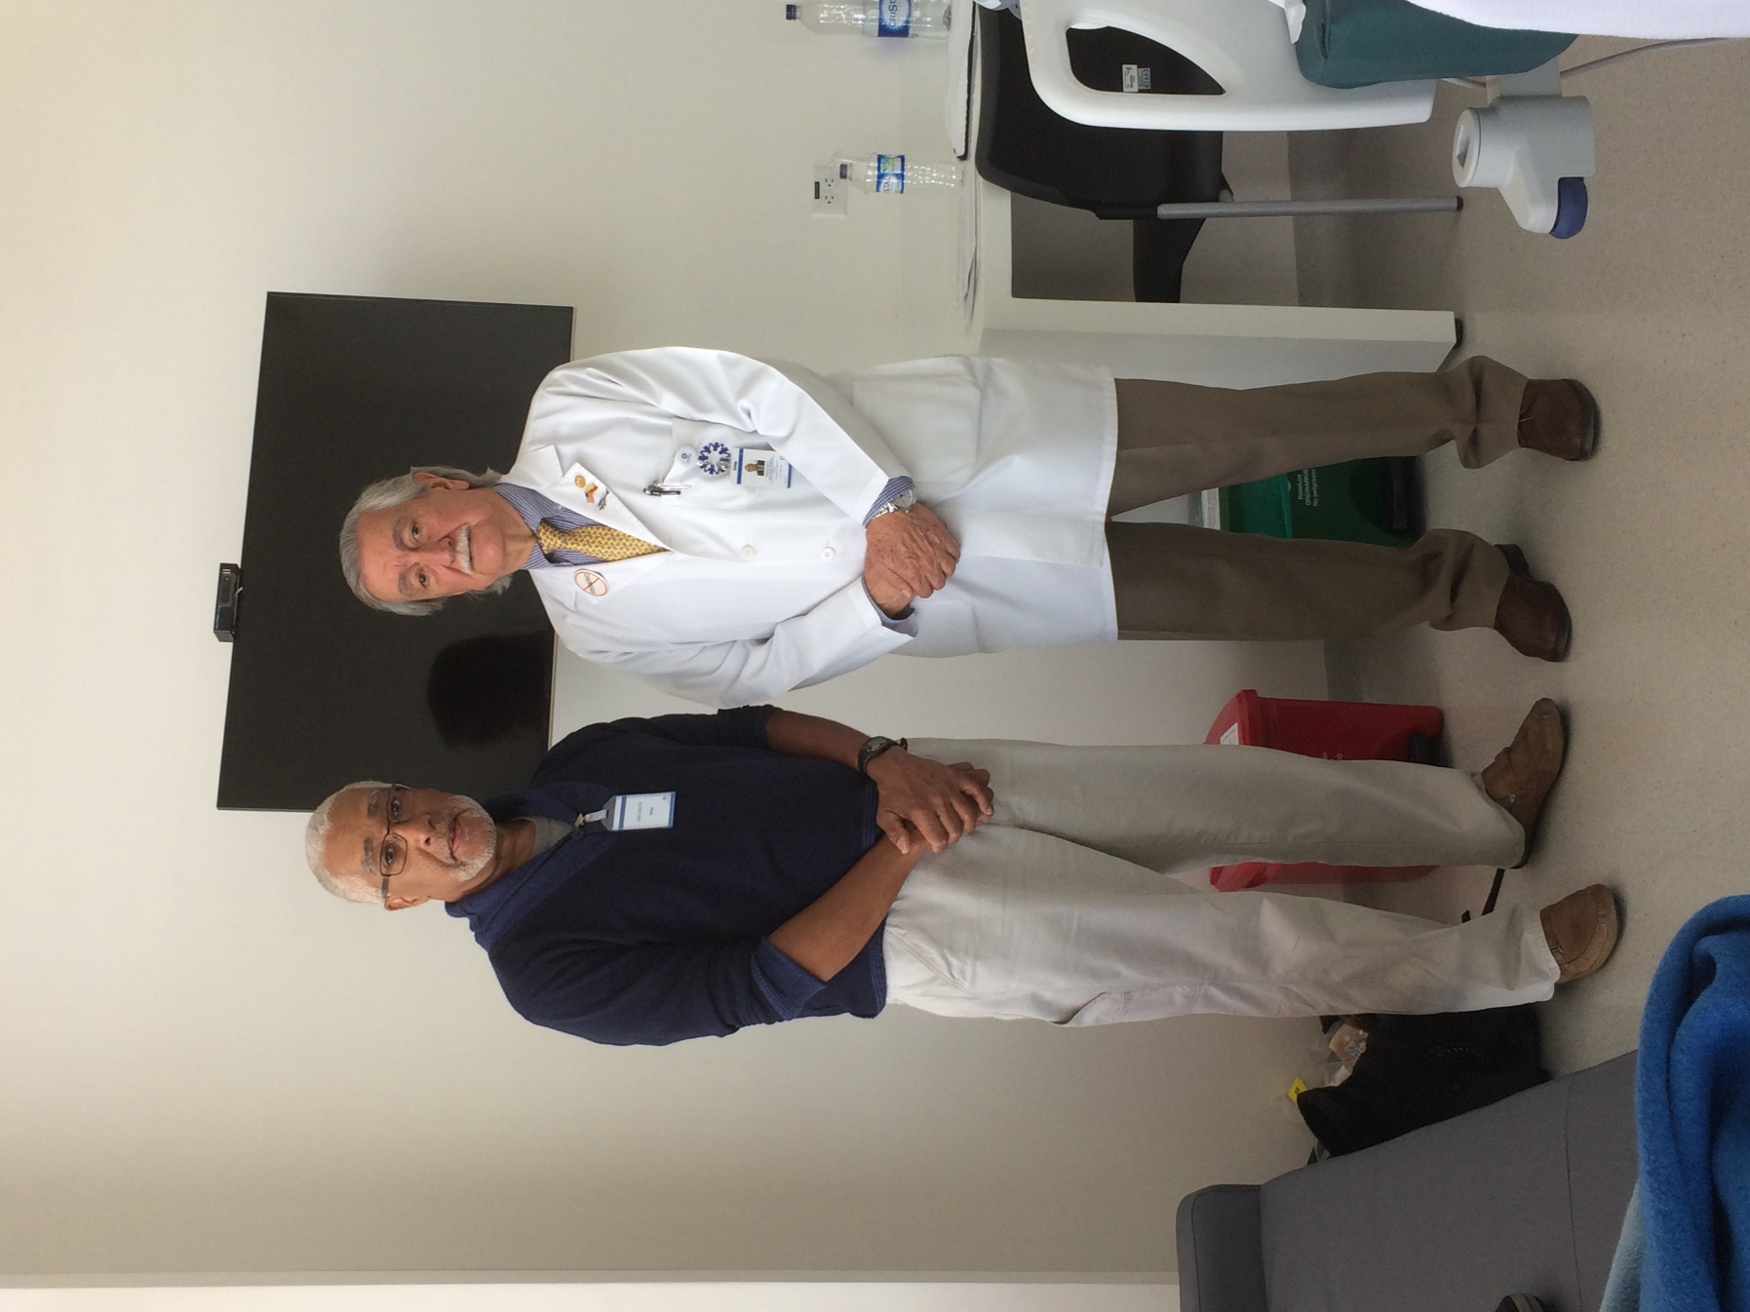
David Jacobs, MD with Dr. Francisco Holguin
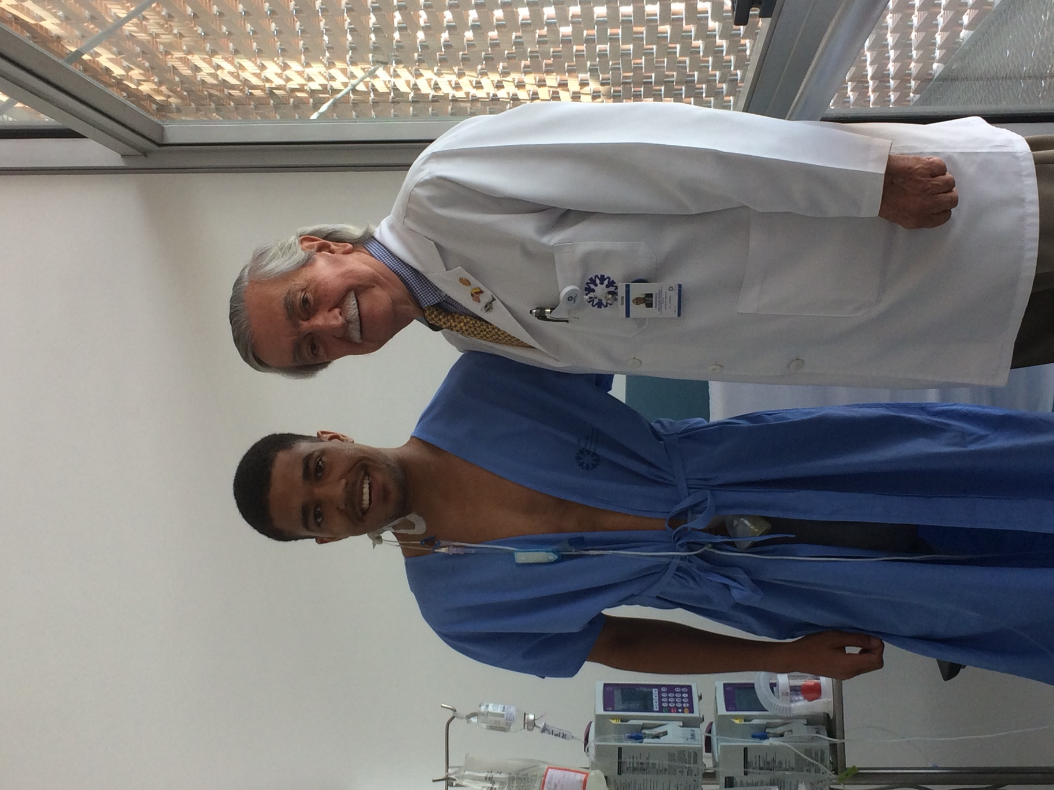
Ethan A Jacobs with Dr. Francisco Holguin
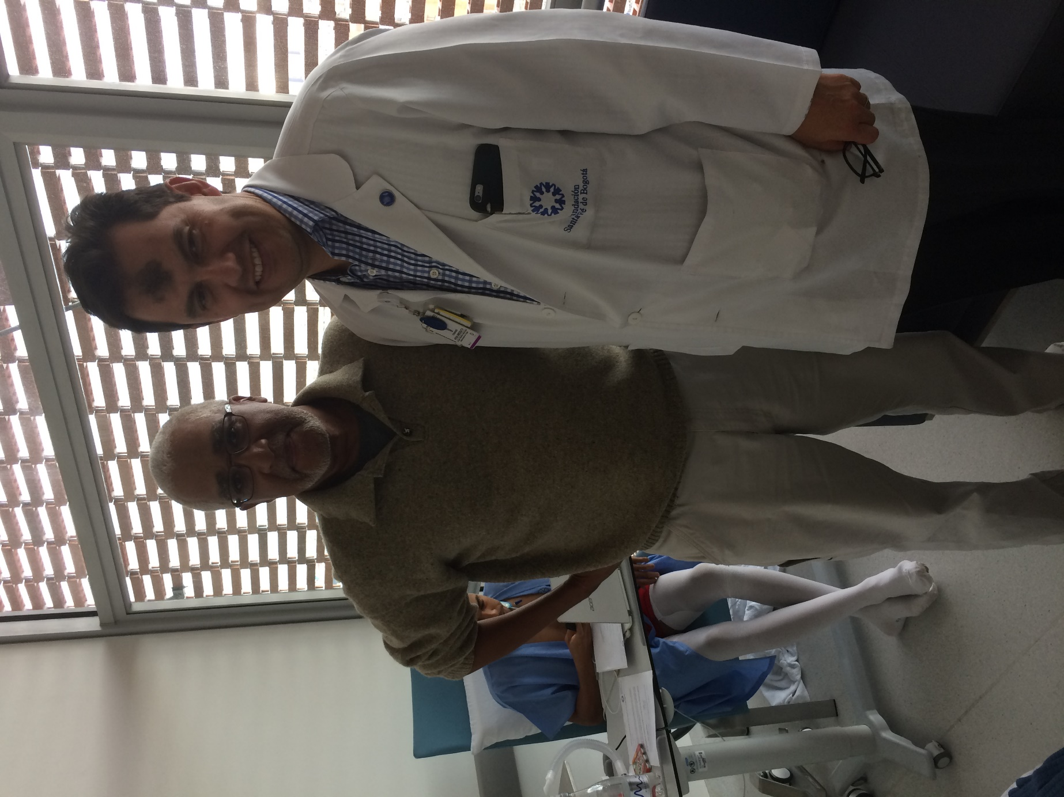
David Jacobs with Fernando Arias, MD
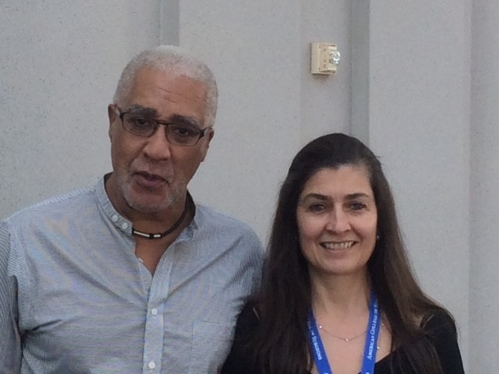
David Jacobs with Maria F. Jimenez, MD
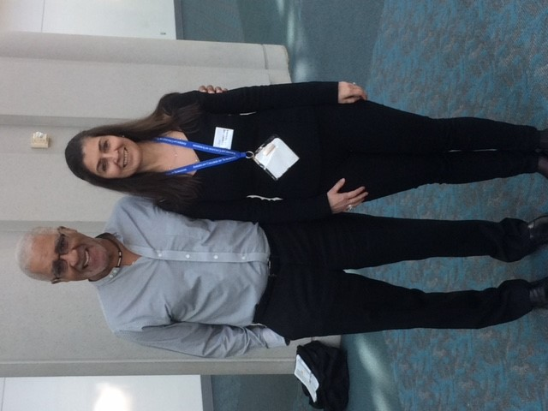
David Jacobs with Maria F. Jimenez, MD

