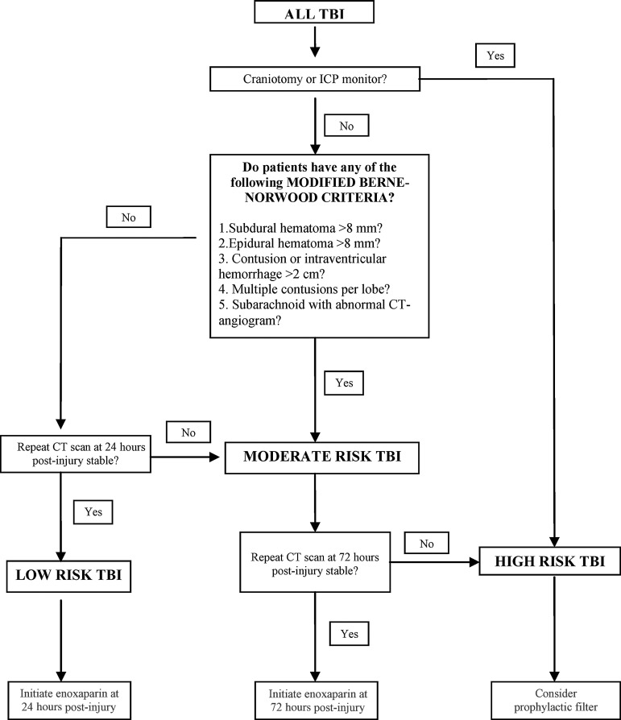

Documentation of medical decision making = compliance with the guidelines

- Primary compliance measures
  - Timing to anticoagulant therapy
    - Low Risk – 24 hours
    - Moderate Risk – 72 hours
    - High Risk – 72 hours, consider IVC filter

