AAST Acute Care Surgery Didactic Curriculum

Thoracoabdominal and Diaphragm Injury
Rita Brintzenhoff, MD

Highlights:
- Imaging (X-ray and CT) has low sensitivity for diaphragm hernias.
- Delayed recognition of traumatic diaphragm hernias has a mortality of over 10%.
- Hemodynamically stable patients without peritonitis with penetrating right-sided diaphragm injuries or penetrating posterior left-sided diaphragm injuries may be amenable to non-operative management.
- Transabdominal approach is preferred in acute traumatic injuries whereas thoracic approach may be beneficial if there is no concern for visceral ischemia and the herniated contents would be difficult to reduce transabdominally.
- The choice of suture and the use of mesh remains controversial in the repair of diaphragmatic hernias.

Background
- Prevalence
  - Incidence: 0.46% of all entries in the National Trauma Data Bank (NTDB). This is likely underestimated due to lack of imaging sensitivity¹
  - Other studies have reported higher estimates using non-NTDB sources:
    - 2.1% of blunt trauma²
    - 3.5% of penetrating trauma²
  - ~65% are a result of penetrating trauma (two thirds of these are from gunshot wounds, one third from stab wound). 33% are a result of non-penetrating trauma (two thirds of these are from motor vehicle crashes)^{1,2}
- Left-sided diaphragm injuries are more common (50-80%) due to the protective nature of the bare area of the liver on the right side.²³
- Diaphragm hernias can result in 25-50% decrease in pulmonary function which explains why the most common symptom of a diaphragmatic hernia is dyspnea (86%) and the second most common symptom is abdominal pain (17%).²
- Delayed recognition frequently presents as a surgical emergency (50%) with mortality of 11% ⁴

Diagnostic Considerations
- When to be concerned a diaphragm injury may have occurred:
  - Possible defect on CT (usually seen best on coronal and sagittal views).
  - Injuries on both sides of the diaphragm after penetrating trauma
  - Nasogastric tube curls up into pleural space after crossing the lower esophageal sphincter
  - Unexplained hypoxia
- Up to 62% of patients with traumatic diaphragm hernias have normal chest X-rays.²
- Chest X-ray sensitivity for left-sided diaphragm hernias is 2-60% and 17-33% for right-sided hernias
- CT: sensitivity 0.77 (95% CI, 0.72-0.82) and specificity 0.91 (95% CI, 0.88-0.92)
- Laparoscopy: sensitivity 0.98 (95% CI, 0.88-1.00) and specificity 1.00 (95% CI, 0.97-1.00) – complication rate of 2.2% (6 of 273). ⁵
- Due to the low sensitivity of CT scan, and the high sensitivity of diagnosis of traumatic diaphragm hernia at laparoscopy, the EAST Working Group Recommendation is: “In left thoracoabdominal stab wound patients who are hemodynamically stable and without peritonitis, we conditionally recommend laparoscopy rather that computed tomography to decrease the incidence missed diaphragmatic injury.” ⁵
- There is a high rate of associated injuries with traumatic diaphragm injury in patients suffer both blunt and penetrating traumas.
  - Injuries associated with blunt traumatic diaphragm injury: 48.7% pulmonary, 44.8% spleen, 39.7% liver, 30.0% pneumothorax, 21.5% hemothorax, 17.3% kidney
  - Injuries associated with penetrating diaphragm injury: 53.6% liver, 29.1% spleen, 28.1% pulmonary, 26.6% stomach, 26.3% hemothorax, 20.4% pneumothorax

Example of a chest X-ray that was later found to have a massive left diaphragm hernia.
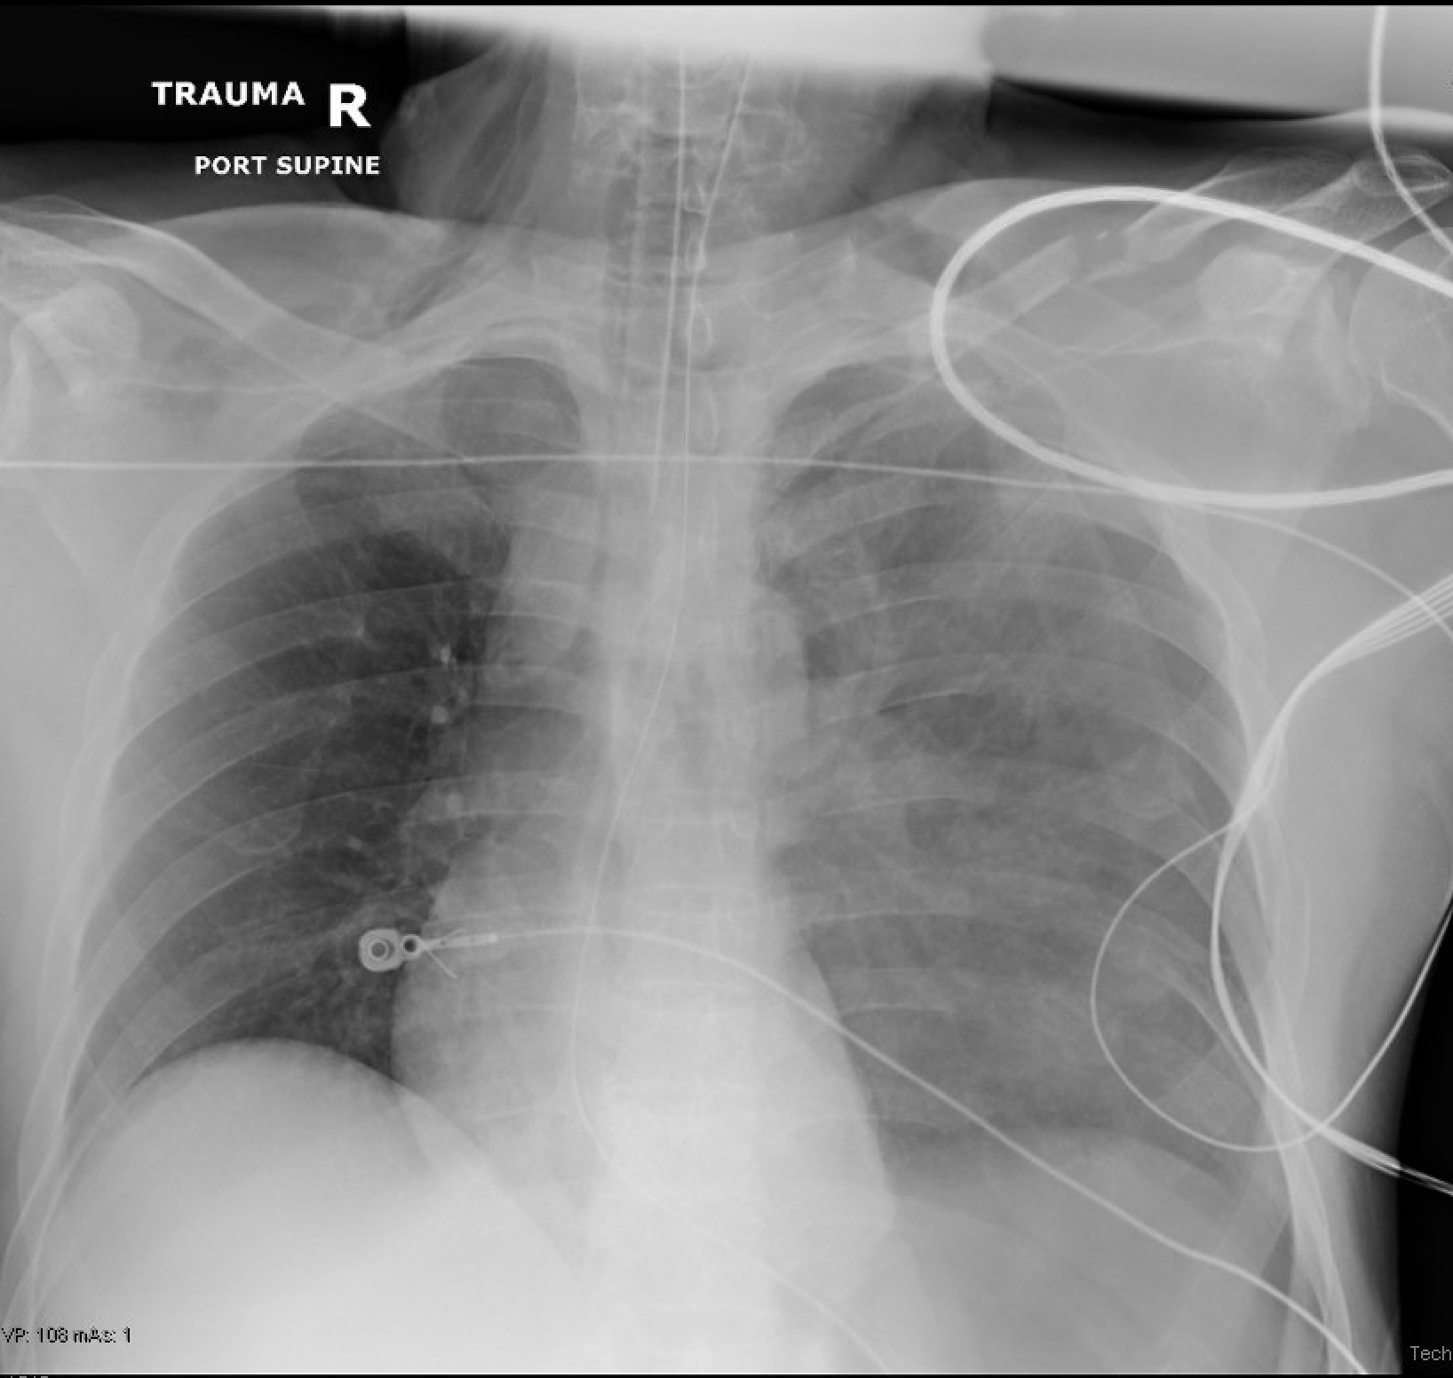
Note a hemothorax on the left for which a tube thoracostomy was placed and then he underwent CT scan.
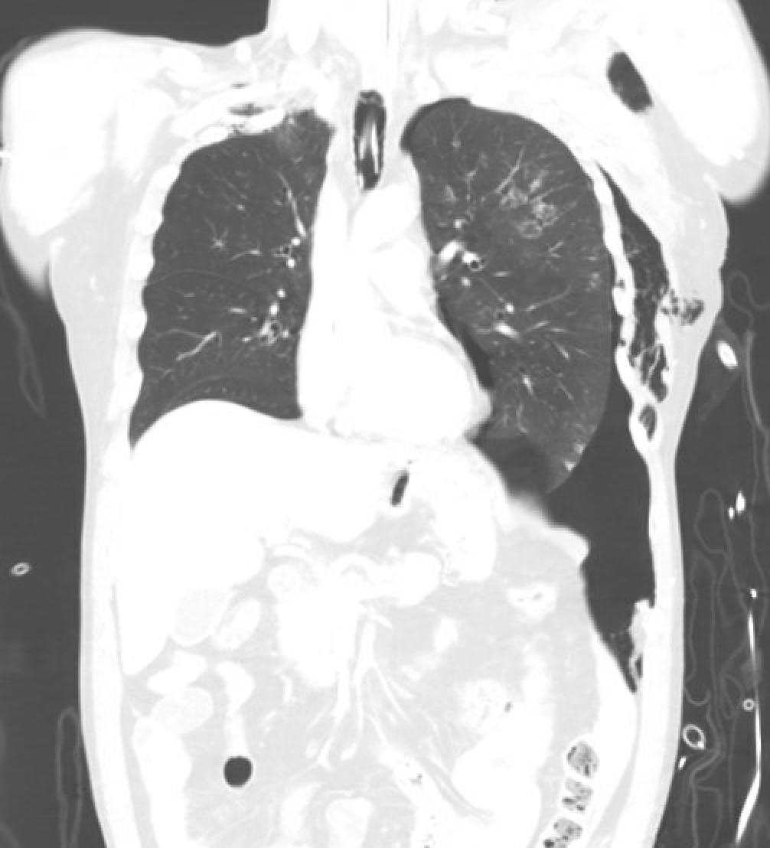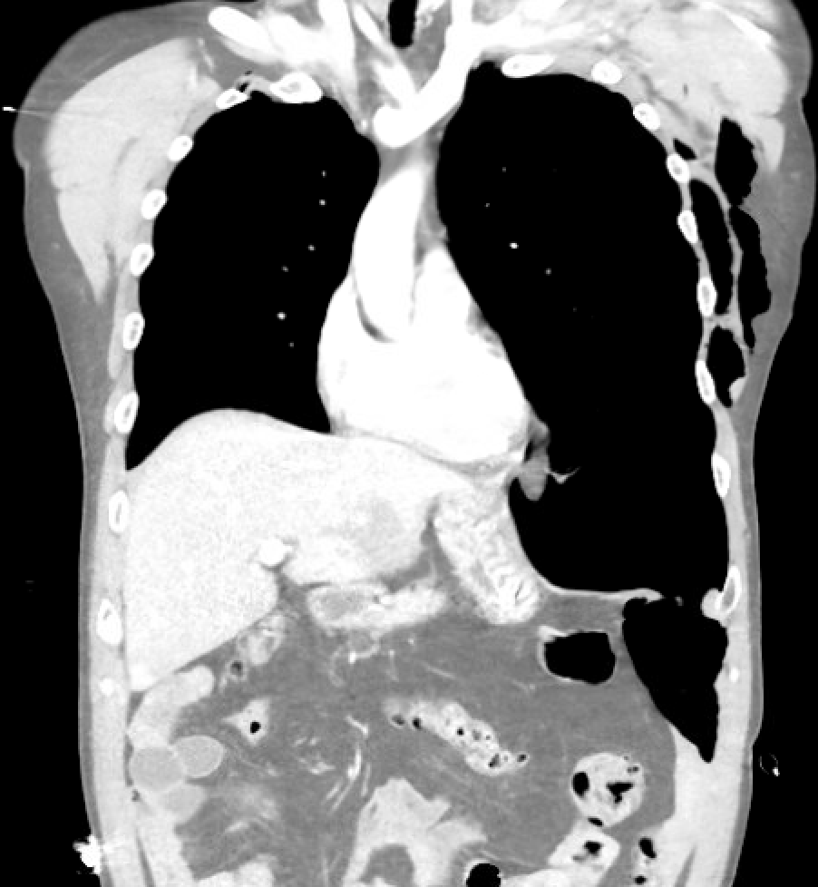
Note the left pneumothorax and left diaphragm disruption. Intraoperatively he was found to have the entire posterior and lateral diaphragm torn off from its attachment to the thorax.

AAST Diaphragm Injury Scale
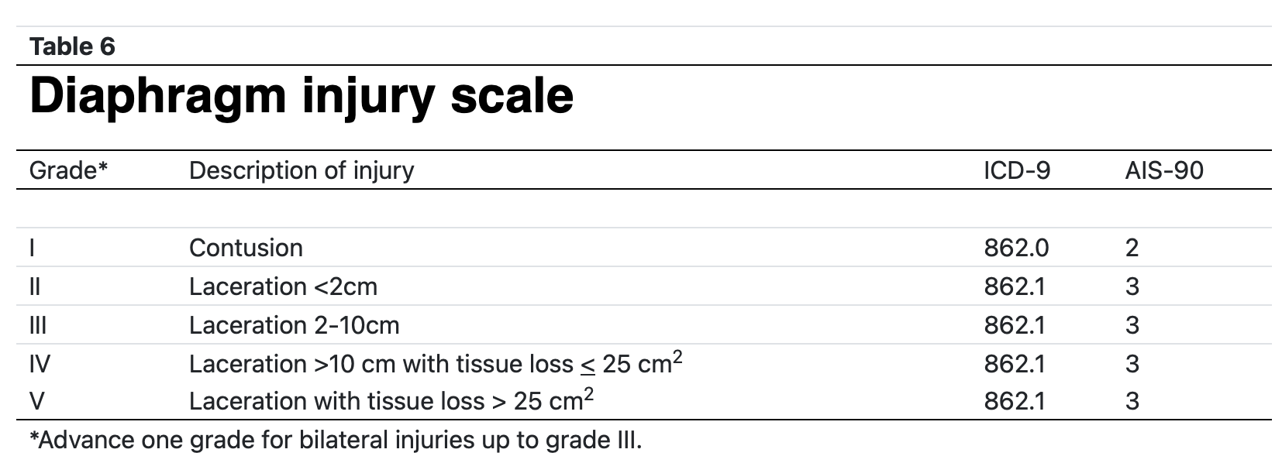
From Moore et al. ⁶

Non-Operative Management of Right-Sided and Posterior Thoracoabdominal Injuries
- Patient must be hemodynamically stable without peritonitis.
- Right-sided and posterior penetrating wounds have been managed non-operatively.
- Ertekin et al. found no major morbidity or mortality at average of 13 month follow up in all four patients with right-sided injuries.
- Non-operative management of a right sided traumatic diaphragm injury can result in a bilothorax which can either be managed operatively with repair of diaphragm defect or non-operatively following same pathway as intraperitoneal bile leaks.
- Murray et al., had a report of 28 patients with delayed diaphragmatic hernia from traumatic diaphragm injury and only one of those patients had a right-sided injury.¹

Surgical Approach Considerations
- The majority (about 80% or higher) are performed via abdominal approach and abdominal approach is conditionally recommended by the EAST task force and strongly recommended by the WSES task force.^{2,5}
- Consider thoracoscopic approach for right-sided stab wounds with concern for diaphragm injury in the stable patient. ⁵
- For repair of diaphragmatic hernias recognized in a delayed manner, the transthoracic approach had a higher incidence of pneumonia but otherwise there was no difference noted in the study of 28 patients and there are no available high quality studies to recommend one approach over the other.⁴
- Consider abdominal approach when there is concern for visceral ischemia. Consider thoracic approach if preoperative imaging suggests that reducing hernia contents from the abdomen may be more difficult.
- Approach may be dictated by other injuries based on penetrating trajectory or imaging findings if available.
- There is wide variability on how to repair a diaphragm hernia. The following are some of the ways repair has been described but due to no high quality evidence one technique cannot be recommended over another:
  - 2-0 or larger suture, monofilament or braided, permanent or absorbable.
  - Some advocate to use mesh to repair larger defects after primary closure².
  - The WSES task force advocates to use interrupted, non-absorbable 2-0 or 0 monofilament or braided sutures in two layers with mesh on-lay for defects greater than 3 cm.²
  - The use of mesh on the diaphragm remains a controversial topic.
- For injuries adjacent to the ribs, the diaphragm can be fixated to the lower ribs using sutures that encircle the rib and if there is tissue loss the diaphragm can be sutured to a higher rib to allow for less tension. ²
- Some surgeons advocate for robotic-assisted (over laparoscopic) transabdominal approach to diaphragm closure which has been safely utilized.
