September 2024

Pediatric Committee
Collaborative Resources for Initial Pediatric Trauma Management: Imaging, MTP, and sTBI
Written by: Aaron R. Jensen, MD, MEd, MS, FACS, FAAP

Most children receive initial post-injury care at hospitals that are not pediatric trauma centers. Emergency Department Pediatric Readiness has been shown to have an independent association with improved risk-adjusted survival and is increasingly being emphasized at trauma centers. While the availability of pediatric-sized supplies and equipment tends to receive the greatest emphasis in pediatric readiness discussions, pediatric-specific management protocols are an equally important aspect of pediatric readiness. A 2021 Delphi analysis identified imaging guidelines, pediatric hemorrhagic shock, and pediatric traumatic brain injury (TBI) as the top priorities for improving quality in pediatric trauma care. To address these needs, the Emergency Medical Services for Children (EMSC) Innovation and Improvement Center (EIIC) has developed standardized one-paged ‘just in time’ resources for use among centers that may not routinely care for children as a part of the Pediatric Education and Advocacy Kit (PEAK) for multisystem trauma (available free at https://bit.ly/PEAKtrauma). These resources include specific guidance on the use of advanced cross-sectional imaging, severe TBI resuscitation, and hemorrhagic shock recognition and management including massive transfusion. This article aims to provide a high-level overview of these resources and promote dissemination among trauma centers for use in collaborative consultation with regional pediatric trauma centers that provide definitive management of injured children.

Cross-sectional imaging is likely overutilized in children and evidence-based clinical decision rules have previously been developed to safely decrease the use of CT for pediatric trauma evaluation. Avoiding unnecessary CT scanning in children is important, as a significant increase in downstream induced malignancy has been demonstrated in patients with appendicitis diagnosed with CT rather than ultrasound alone. While whole body CT (WBCT) is routinely utilized in high-mechanism trauma for adults due to lower missed injury rates and faster time to diagnosis of injuries, these benefits are not as great in children. Due to clear anatomy on plain radiographs and the greater risks of radiation in children, WBCT should be reserved for children that have both a high-energy mechanism, an unreliable exam due to severe neurotrauma, and a need for rapid diagnosis of all injuries in children that may need to be in the operating room for craniotomy. Selective body region-specific scanning should be implemented in children based on evidence-based clinical decision rules. The Pediatric Emergency Care Applied Research Network (PECARN) has developed robust clinical decision rules for Head CT, but outside of this rule, clinical decision rules have not been widely adopted and implementation gaps persist. PECARN rules for cervical spine injury have recently been published and provide an evidence-based framework for clinical clearance of the cervical spine in children without the routine use of imaging. These rules, while providing guidance on which children to image, are limited in guidance for how to manage children that do not meet criteria for clinical clearance – specifically when a collar can be removed with negative imaging and persistent symptoms. Formal clinical decision rules have not been proposed for chest CT, but evidence supports reserving chest CT for ruling out mediastinal vascular injury in the presence of an abnormal chest radiograph. Several differing (but complementary) decision rules have been developed for abdominal CT and have been integrated into a single pathway (Figure). Trauma centers can use standardized imaging guidelines to promote communication between centers for quality improvement, and encourage consistent imaging practices across regions and potentially decrease unnecessary CT scans in children.

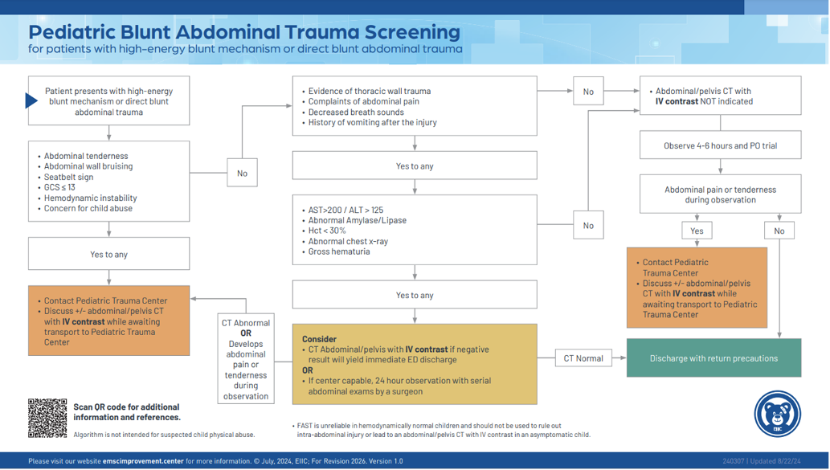
Figure 1: Pediatric Abdominal CT Clinical Decision Algorithm. Copyright EMSC Innovation and Improvement Center 2024. Used with permission.

Hemorrhagic shock is a leading cause of preventable mortality in injured children. While the data supporting high-ratio transfusion in children is not as strong as it is in adults, the available evidence does suggest the same benefit. Shock recognition in children can be challenging due to the nonspecific nature of tachycardia (which is often due to pain or fear), the delayed onset of hypotension due to profound compensatory mechanisms in children, and general unfamiliarity of normal vital signs in children. Implementing tools such as the ABC-D score to identify patients with significant hemorrhage can lead to earlier activation of massive transfusion protocols and potentially improved outcomes. Due to the small circulating blood volume of young children, reliance on adult massive transfusion protocols can lead to early unbalanced transfusion (for example, giving a single 300cc ‘unit’ of red blood cells to a 10 kg child is equivalent to giving an adult six units of RBCs to an adult). Many adult massive transfusion protocols start 1:1 transfusion ratios after four units of RBCs, which can lead to early exacerbation of coagulopathy in small children if plasma is not introduced long before the fourth unit of RBCs is started. The EIIC hemorrhagic shock resource includes normal vital signs references, shock identification tools, and an example weight-based pediatric massive transfusion protocol that can be implemented in centers without an existing pediatric protocol.

Timely recognition and treatment of severe TBI is essential for optimization of outcomes for children. Assessing GCS may be challenging if clinicians are unfamiliar with the pediatric GCS scale. Resuscitation algorithms for pediatric sTBI are similar to adults with a few minor differences. The Brain Trauma Foundation recommends 3% saline in children and does not recommend the routine use of mannitol for intracranial hypertension. ATLS principles should be optimized, with early recognition of a patient that exceeds institutional resources a key step in optimizing time to definitive care. Obtaining head CT should not delay transfer out to higher level of care unless it can be obtained while transport assets are being mobilized. CT should be performed in collaboration with a regional pediatric center to ensure appropriate images are obtained and minimize re-scanning after transfer. The EIIC TBI resuscitation algorithm provides just-in-time guidance including calculation of pediatric GCS, prioritization of ATLS principles, indications for endotracheal intubation, and guidance on neuroprotective and osmotic agents.

These resources are intended for primary use at centers that infrequently care for children and do not have the full spectrum of definitive management resources. They are also intended for pediatric centers to use for education and outreach as a discussion point to improve collaborative care regionally. Standardization of care can decrease variability and potentially improve outcomes. The use of shared resources has the potential to support this standardization and use of these resources should be encouraged to promote collaboration between pediatric trauma centers and their regional partners.

