November 2023

Pediatric Trauma Committee

Pediatric Vascular Trauma: Who will be responsible for these injuries?
Written by: Matthew T. Harting, MD, MS, Natalie Drucker, MD, MS, S. Keisin Wang MD, Charles S. Cox, Jr, MD

Take Away Messages:
- Pediatric vascular trauma (PVT) demands a timely, expert, and unique response, including specialized development and maintenance of an advanced skillset, in order to optimize outcomes.
- While variable, the structure of a vascular response team must include continual and immediate availability of trauma, pediatric, and vascular expertise.
- Open repair remains the mainstay for managing most injuries with less of a role for endovascular repairs.
Pediatric vascular trauma represents a complex intersection between vascular surgery, trauma surgery, and pediatric surgery. With changing paradigms of surgical training, a gap has developed in many institutions in terms of who is principally responsible for children with vascular injuries. To that end, we sought to examine our approach to integrated trauma vascular care and what models may exist in other facilities. Finally, the issue of endovascular therapies comes up in dealing with older children and is worthy of discussion. A review of all of the components of individual injuries is beyond the scope of this communication.

As of 2020, penetrating injuries became the leading cause of death among children and adolescents age 1-19 in the United States. Among these patients who survive to reach advanced medical care, vascular injuries are associated with significant morbidity, along with challenges around patient ownership and expertise. These injuries can lead to life-threatening hemorrhage and limb-threatening ischemia if not addressed in a timely manner. Vascular injury management demands unique expertise, which is particularly nuanced for the pediatric patient. An integrated team may provide the best approach to rapid hemorrhage control and revascularization, though the structure of vascular response teams in children’s hospitals is highly variable. Herein, we will highlight the scope of the epidemic of traumatic vascular injuries in pediatric patients, provide an overview of current evidence and outcomes, discuss the variability of team structure, identify training opportunities for maintenance of expertise, and provide overarching team structure strategies. Finally, we provide a high-level look at initial resuscitation and address endovascular approaches and limitations, germane to pediatric vascular trauma (PVT).

Outcomes and experience
Frequency and outcomes in PVT vary by injury mechanism, location, severity of injury, and a myriad of other factors. Vascular injuries are infrequent in the pediatric trauma patient, comprising 0.6-2% of all injured patients.¹ Despite this low incidence, extremity vascular injuries in children are associated with limb loss rates between 2% and 11%, along with an overall mortality range of 0-15%.²⁻⁴
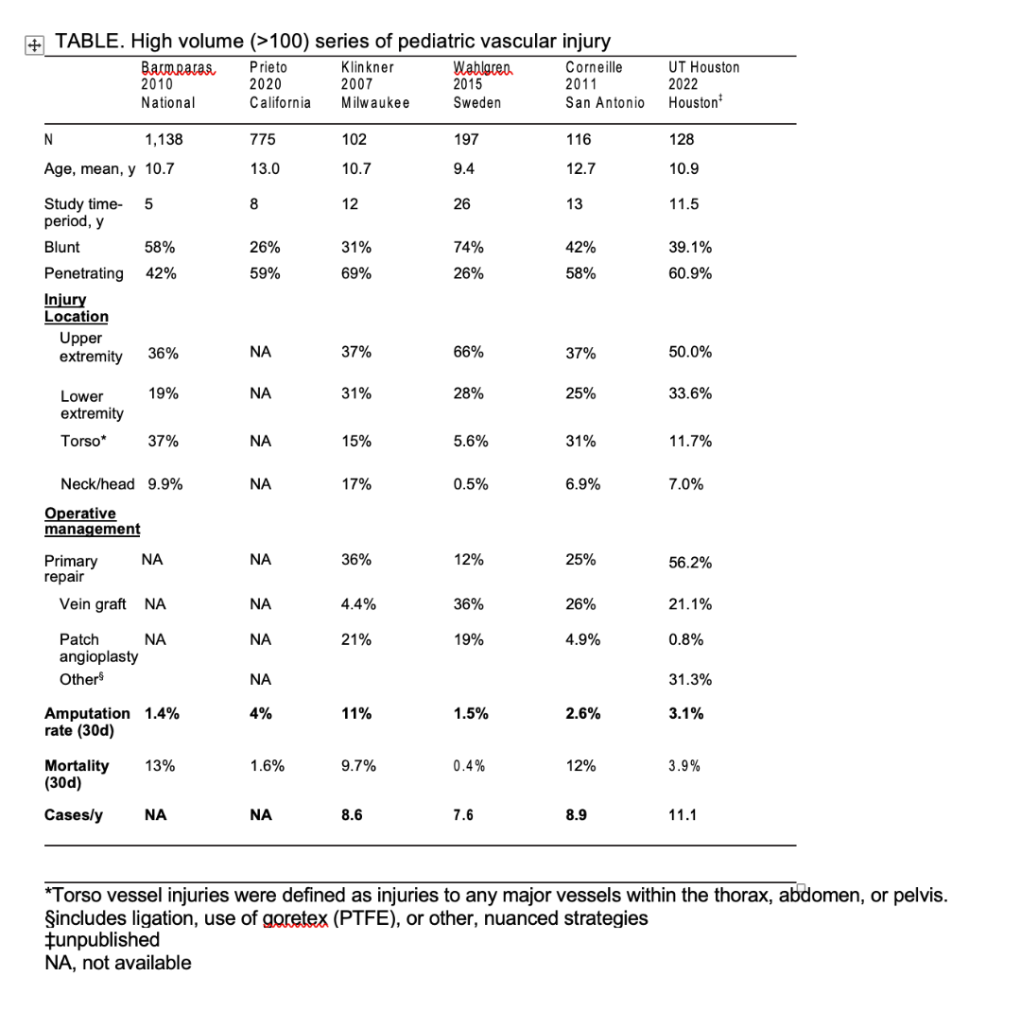
^{1,2,5-7} Vascular injuries in younger pediatric patients are more likely the result of a blunt injury,⁴ though this transitions to penetrating injuries in the mid-teens. While thoracic and abdominal vascular injuries occur, the upper and lower extremities are the most and second most common vessel injury locations, respectively.^{4,6} Vascular injuries increase in frequency with increasing age and are twice as likely in boys.⁴While still rare overall, frequency of pediatric vascular trauma (PVT) may be increasing over time; fortunately, mortality is likely improving.³

Pediatric vascular team variability and maintenance of expertise
The specific design, structure, and function of the team that responds to and manages PVT is highly variable by center.⁸ Classic models have the injured patient cared for by the trauma service, consulting vascular surgeons or interventional and neurointerventional radiologists as appropriate.. This adult model translates poorly into children’s hospitals and has led to variable outcomes in PVT. The forces that have led to this variability are numerous. First, there has been a shift in surgical training leading to less comfort with open vascular procedures. This is due to the increase in the application of endovascular approaches (with a concomitant decrease in open vascular procedures),^{9,10} the rise of the integrated vascular surgery training paradigm,¹¹ and the increasing forces of sub-specialization.¹² The result is trauma surgeons, general surgeons, and vascular surgeons with an overall decreased collective open vascular experience and comfort,^{13,14} leaving them less equipped to handle emergent exposure, decision-making, and reconstruction.⁸ Second, the infrequency of PVT requires those with vascular trauma expertise to also practice within a specialty which provides alternative volume; a practice isolated to PVT could not exist. Third, shifts in call coverage and infrequency of exposure render maintenance of expertise and availability increasingly challenging.
Fourth, the pediatric population is a highly individualized population, where patient size, potential for growth, and unique physiology lead to decreased overall comfort level for both adult¹⁵ and pediatric¹⁶providers. Fifth, the urgency of the intervention limits the opportunity for centralization of highly expert care, increasing the dilution of the experience, while requiring numerous centers to develop an often-imperfect solution to this clinical need. Delay in intervention, secondary to untimely diagnosis or transport, prolongs ischemic times and worsens outcomes.¹⁷ Sixth, centers have highly variable personnel constructs, historical cultures, and volumes. Free-standing children’s hospitals and children’s hospitals within adult centers have unique resource availability.¹⁶ American College of Surgeons (ACS)-verified pediatric and adult trauma centers are different than non-ACS-verified centers,⁴ with notable variability in availability of expertise specific to PVT. Further, trauma volume is variable by center.¹⁸ Seventh, prehospital care and emergency department expertise is highly variable. Prompt recognition and early, appropriate diagnostics with efficient, early resuscitation are key to the function of a high-level trauma center.

There are a number of training options for the pediatric surgeon or trauma surgeon to gain and maintain expertise within a team caring for the PVT patient. The role and scope of responsibility ranges from total perioperative care to surgical procedure to coordination of management of the multiply injured patient. There are specific courses related to vascular exposures in trauma (ASSET Course: Advanced Surgical Skills for Exposure in Trauma as one example).^{19,20} There are various components of pediatric surgical practice that can include vascular surgical procedures such as extracorporeal life support (ECLS or ECMO) vascular reconstruction, vascular ring management, composite vascular-tumor reconstructions, along with vascular trauma. The ASSET course includes both cognitive didactic and technical hands-on cadaver dissection opportunities. Evidence suggests that ASSET training improves exposure techniques, procedure competency/efficiency, and rate of successful vascular control.²¹ Moreover, although the course enables surgical residents to reach an expert competency level, interval experience affected skill retention at 18 months.²² Clearly, baseline education, combined with consistent experience, establishes and maintains an expert level of competency. Therefore, even if the pediatric surgeon ultimately isn’t tasked with the repair of the injured vessel, the exposure, vascular control, potential for shunting, and use of fasciotomy can be performed concomitantly with a consultant who performs the revascularization.

As another example, resuscitative endovascular balloon occlusion of the aorta (REBOA) is being employed with increasing frequency, given evidence of its efficacy.²³ It can serve as a resuscitative adjunct in patients in hemorrhagic shock, including adolescent and pediatric patients.²⁴ Due to size limitations, this effort is focused on adolescents, although there are published guidelines on balloon inflation volumes for smaller patients,²⁵ and a newer 4-French device (COBRA–OS, Frontline Medical, Ontario) is now FDA approved and widely used. Training, experience, trauma system processes, and expertise are associated with increased rates of successful use of this technique.^{26,27} Finally, high-fidelity simulation, anatomically accurate modeling, and human tissue-like physical models all allow development and maintenance of skills in a risk-free environment. Virtual reality simulation has been used to effectively teach REBOA skills.²⁸Additionally, objective structured clinical examination (OSCE) training for surgical skills is effective in improving proficiency and self-confidence.²⁹ Vascular anastomosis-specific training has been employed for the development of the basic technical skills required for vascular surgery.³⁰

Optimizing pediatric vascular team structure
How are we to reconcile these challenges and forces to maintain timely and expert care of PVT? Fortunately, there are likely multiple solutions, as optimal outcomes in PVT may be achievable through several unique structures and with the involvement of various specialties. Outcomes in vascular trauma have repeatedly been shown to be specialty independent,^{10,31,32} therefore the composition of an effective team may take on many forms, depending on the specific hospital or institution. Several overarching construct options include:

Option 1: Comprehensive surgical management via centralized expertise. A pediatric or adult trauma-trained surgeon who has experience and expertise in pediatric trauma, vascular control and definitive repair leads a team. This individual (or, ideally, a team of individuals) are consistently available, along with operating room (OR) team availability and expertise. A separate microvascular reconstruction (often hand or plastics) team is available. Further, all necessary imaging and operative equipment are available. The risk of Option 1 is the lack of depth of expertise for complex repairs and the need for an “Option 1.5” in terms of occasional vascular consultation.

Option 2: Trauma surgeon leadership with focused consultation. A pediatric and/or adult trauma-trained surgeon leads initial stabilization, diagnosis, resuscitation, exposure, and control with possible shunting. A vascular surgeon with significant experience in open repair/trauma consults for intraoperative technical expertise. A separate microvascular reconstruction team is available. OR team availability and expertise exist, and all necessary imaging and operative equipment are available. The risk of Option 2 is a niche vascular surgical specialist may not be a useful consultant (for example, a specialist in endovascular aortic disease or practice limited to venous disease). Avoidance of this requires frank discussions regarding call coverage before forming the team.

Option 3: Trauma surgeon stabilization with broad consultation. A pediatric and/or adult trauma-trained surgeon leads initial stabilization, diagnosis, and resuscitation. Consultation with appropriate expertise* occurs for exposure, control, and definitive repair. OR team availability and expertise exist, and all necessary imaging and operative equipment are available. The risk of Option 3 is management by committee and loss of prioritization of patient physiology as a polytrauma patient..
*open vascular surgery, endovascular, transplant, pediatric cardiovascular, and/or microvascular reconstruction

Initial resuscitation, evaluation, and imaging in PVT
After a fundamental trauma assessment with thorough primary and secondary surveys, a focused vascular physical examination should be performed. . Pediatric trauma resuscitation and massive transfusion protocols have been widely adapted from initial work in adults.³³ Three evolving elements of resuscitation practice in children are (1) use of low titer O negative, whole blood resuscitation vs. balanced ratios of PRBC:FFP;PLT,³⁴ (2) thromboelastography (TEG) driven component replacement,³⁵ and (3) tranexamic acid, or TXA as an adjunct to hemorrhage control, either prophylactically or in setting of fibrinolysis³⁶ on TEG.^{37,38}

A threatened limb or other potential vascular injury should be identified on examination with hard or soft signs of vascular injury and a subsequent arterial pressure index. This is accomplished with a doppler probe, a blood pressure cuff, and the following formula: API=doppler systolic pressure distal to injury/doppler systolic pressure of an uninjured upper extremity. An API<0.9 is both highly sensitive (>95%) and specific (>97%) for arterial injury, even for the pediatric patient.^{39,40} If the doppler signal interrogation or API support the concern for vascular injury, one of three modalities should be used to further characterize the injury: digital subtraction angiography (DSA), duplex ultrasonography, or computed tomography arteriography (CTA). CTA has become the most utilized approach, particularly for the pediatric patient, due to its availability, excellent image quality, high sensitivity and specificity, and these patients often require this imaging for associated injuries.

Endovascular approach for pediatric extremity injury?
There is a very limited role for endovascular treatment for prepubertal upper extremity trauma due to a combination small vessels, easy open exposure for the mid and distal arm, and poor durability in the long-term.⁴¹ Therefore, we believe, and evidence supports, the only reason for endovascular intervention in the pediatric population is to treat sites in which proximal control cannot be easily obtained or is associated with significant morbidity such as axillosubclavian injuries.⁴²⁻⁴⁵ In these situations, if the patient is unstable or has multiple sites of concomitant injury, it may be beneficial to temporize the patient with a stent-graft to rapidly re-establish distal perfusion and deal with the repercussions in a more elective manner as they materialize. Commercially available self-expandible peripheral stents span from 5-13 mm (Viabahn Endoprosthesis, W.L. Gore and Associates) and should be sized 5-10% over the target vessel diameter.⁴⁶ In a catastrophic limb injury, embolization of branch points with evidence of extravasation can be considered in very select patients but not recommended, once again, due to general ease of surgical access without the need to leave foreign materials. Postoperatively, dual antiplatelet pharmacologic treatment with a baby aspirin and clopidogrel is preferred for at least three months while aspirin is continued indefinitely to maintain graft patency.⁴⁷

Open surgical reconstruction remains the pillar of lower extremity vascular trauma in the pediatric patient. The same principles for pre- and post-pubertal patients described in other vascular beds remain true for the lower extremity. However, we have found several instances where endovascular intervention may be potentially useful; these cases are universally situations where the open exposure of an arterial bed will cause significant morbidity. For example, the patient with distal profunda femoral artery injury in which exposure will lead to significant bleeding and need for transection of thigh musculature or the patient with a proximal anterior tibial artery injury in which there is no easy way to expose the interosseus portion without potential injury to the bridging anterior tibial vein while maintaining proximal and distal control. ⁶ These cases may be better suited with coil embolization, particularly if concomitant injuries or challenging anatomy complicate the situation, given the presence of excellent collaterals in these locations.

Do I need a Hybrid Room?
The short answer to this question is YES. There are growing indications for use of the Hybrid Room in which advanced imaging can be done upon completion of a vascular repair.⁴² Importantly, there is the ability to expand the management of complex truncal injuries using balloon catheters, ECMO cannulation with imaging, and other contingency equipment and/or the use for embolization of solid organ injuries or pelvic injuries.^{43,44}

Conclusions
The time to formulate the optimal approach to PVT is prior to the presentation of the patient with a critical injury. Critical review of institutional resources and available personnel allows the optimal integration of the team for the uncommon (but increasing in frequency) patient with these injuries.
References
- Barmparas G, Inaba K, Talving P, et al. Pediatric vs adult vascular trauma: a National Trauma Databank review. Journal of Pediatric Surgery. 2010;45(7):1404-1412.
- Corneille MG, Gallup TM, Villa C, et al. Pediatric vascular injuries: acute management and early outcomes. The Journal of Trauma. 2011;70(4):823-828.
- Eslami MH, Saadeddin ZM, Rybin DV, et al. Trends and Outcomes of Pediatric Vascular Injuries in the United States: An Analysis of the National Trauma Data Bank. Annals of Vascular Surgery. 2019;56:52-61.
- Prieto JM, Van Gent JM, Calvo RY, et al. Pediatric extremity vascular trauma: It matters where it is treated. The Journal of Trauma and Acute Care Surgery. 2020;88(4):469-476.
- Klinkner DB, Arca MJ, Lewis BD, Oldham KT, Sato TT. Pediatric vascular injuries: patterns of injury, morbidity, and mortality. Journal of pediatric surgery. 2007;42(1):178-182; discussion 182-173.
- Wahlgren CM, Kragsterman B. Management and outcome of pediatric vascular injuries. The Journal of Trauma and Acute Care Surgery. 2015;79(4):563-567.
- Prieto JM, Van Gent JM, Calvo RY, et al. Evaluating surgical outcomes in pediatric extremity vascular trauma. Journal of Pediatric Surgery. 2020;55(2):319-323.
- DuBose JJ, Morrison JJ, Scalea TM, Rasmussen TE, Feliciano DV, Moore EE. Beyond the Crossroads: Who Will be the Caretakers of Vascular Injury Management? Annals of Surgery. 2020;272(2):236-237.
- Forrester JD, Weiser TG, Maggio P, et al. Trends in open vascular surgery for trauma: implications for the future of acute care surgery. The Journal of Surgical Research. 2016;205(1):208-212.
- Scalea TM. Caring for vascular injuries: Training more vascular specialists may not be the answer. The Journal of Trauma and Acute Care Surgery. 2022;92(4):760-761.
- Shannon AH, Robinson WP, 3rd, Hanks JB, Potts JR, 3rd. Impact of New Vascular Fellowship Programs on Vascular Surgery Operative Volume of Residents in Associated General Surgery Programs. Journal of the American College of Surgeons. 2019;228(4):525-532.
- Joels CS, Langan EM, 3rd, Cull DL, Kalbaugh CA, Taylor SM. Effects of increased vascular surgical specialization on general surgery trainees, practicing surgeons, and the provision of vascular surgical care. Journal of the American College of Surgeons. 2009;208(5):692-697, quiz 697 e691; discussion reply 697-699.
- Eckert M, Cuadrado D, Steele S, Brown T, Beekley A, Martin M. The changing face of the general surgeon: national and local trends in resident operative experience. American Journal of Surgery. 2010;199(5):652-656.
- Potts JR, 3rd, Valentine RJ. Declining Resident Experience in Open Vascular Operations Threatens the Status of Vascular Surgery as an Essential Content Area of General Surgery Training. Annals of Surgery. 2018;268(4):665-673.
- Bonasso PC, Dassinger MS, Smeds MR, Moursi MM. Pediatric Vascular Surgical Practice Patterns. Annals of Vascular Surgery. 2019;54:103-109 e108.
- Bonasso PC, Gurien LA, Smith SD, Gowen ME, Dassinger MS. Pediatric vascular trauma practice patterns and resource availability: A survey of American College of Surgeon-designated pediatric trauma centers. The Journal of Trauma and Acute Care Surgery. 2018;84(5):758-761.
- Oller DW, Rutledge R, Clancy T, et al. Vascular injuries in a rural state: a review of 978 patients from a state trauma registry. The Journal of Trauma. 1992;32(6):740-745; discussion 745-746.
- Taghavi S, Jones G, Duchesne J, et al. Impact of trauma center volume on major vascular injury: An analysis of the National Trauma Data Bank (NTDB). American Journal of Surgery. 2020;220(3):787-792.
- Bowyer MW, Kuhls DA, Haskin D, et al. Advanced Surgical Skills for Exposure in Trauma (ASSET): the first 25 courses. The Journal of Surgical Research. 2013;183(2):553-558.
- Kuhls DA, Risucci DA, Bowyer MW, Luchette FA. Advanced surgical skills for exposure in trauma: a new surgical skills cadaver course for surgery residents and fellows. The Journal of Trauma and Acute Care Surgery. 2013;74(2):664-670.
- Mackenzie CF, Garofalo E, Shackelford S, et al. Using an Individual Procedure Score Before and After the Advanced Surgical Skills Exposure for Trauma Course Training to Benchmark a Hemorrhage-Control Performance Metric. J Surg Educ. 2015;72(6):1278-1289.
- Mackenzie CF, Garofalo E, Puche A, et al. Performance of Vascular Exposure and Fasciotomy Among Surgical Residents Before and After Training Compared With Experts. JAMA Surg. 2017;152(6):581-588.
- Bini JK, Hardman C, Morrison J, et al. Survival benefit for pelvic trauma patients undergoing Resuscitative Endovascular Balloon Occlusion of the Aorta: Results of the AAST Aortic Occlusion for Resuscitation in Trauma Acute Care Surgery (AORTA) Registry. Injury. 2022;53(6):2126-2132.
- Theodorou CM, Brenner M, Morrison JJ, et al. Nationwide use of REBOA in adolescent trauma patients: An analysis of the AAST AORTA registry. Injury. 2020;51(11):2512-2516.
- Carrillo L, Skibber M, Kumar A, et al. Morphometric and Physiologic Modeling Study for Endovascular Occlusion in Pediatric Trauma Patients. ASAIO Journal. 2020;66(1):97-104.
- Theodorou CM, Anderson JE, Brenner M, et al. Practice, Practice, Practice! Effect of Resuscitative Endovascular Balloon Occlusion of the Aorta Volume on Outcomes: Data From the AAST AORTA Registry. The Journal of Surgical Research. 2020;253:18-25.
- Theodorou CM, Salcedo ES, DuBose JJ, Galante JM. Hate to Burst Your Balloon: Successful REBOA Use Takes More Than a Course. J Endovasc Resusc Trauma Manag. 2020;4(1):21-29.
- Brenner M, Hoehn M, Pasley J, Dubose J, Stein D, Scalea T. Basic endovascular skills for trauma course: bridging the gap between endovascular techniques and the acute care surgeon. The Journal of Trauma and Acute Care Surgery. 2014;77(2):286-291.
- Ortiz C, Vela J, Contreras C, et al. A new approach for the acquisition of trauma surgical skills: an OSCE type of simulation training program. Surgical Endoscopy. 2022.
- Heelan Gladden AA, Conzen KD, Benge MJ, Gralla J, Kennealey PT. A Vascular Anastomosis Simulation Can Provide a Safe and Effective Environment for Resident Skills Development. J Surg Educ. 2018;75(5):1367-1373.
- Shackford SR, Kahl JE, Calvo RY, et al. Limb salvage after complex repairs of extremity arterial injuries is independent of surgical specialty training. The Journal of Trauma and Acute Care Surgery. 2013;74(3):716-723; discussion 723-714.
- Karam BS, Haberman K, Nguyen P, et al. Trauma surgeon-performed peripheral arterial repairs are associated with equivalent outcomes when compared with vascular surgeons. The Journal of Trauma and Acute Care Surgery. 2022;92(4):754-759.
- King DR. Initial Care of the Severely Injured Patient. The New England Journal of Medicine. 2019;380(8):763-770.
- Anand T, Obaid O, Nelson A, et al. Whole blood hemostatic resuscitation in pediatric trauma: A nationwide propensity-matched analysis. The Journal of Trauma and Acute Care Surgery. 2021;91(4):573-578.
- Vogel AM, Radwan ZA, Cox CS, Jr., Cotton BA. Admission rapid thrombelastography delivers real-time "actionable" data in pediatric trauma. Journal of Pediatric Surgery. 2013;48(6):1371-1376.
- Liras IN, Cotton BA, Cardenas JC, Harting MT. Prevalence and impact of admission hyperfibrinolysis in severely injured pediatric trauma patients. Surgery. 2015;158(3):812-818.
- Eckert MJ, Wertin TM, Tyner SD, Nelson DW, Izenberg S, Martin MJ. Tranexamic acid administration to pediatric trauma patients in a combat setting: The pediatric trauma and tranexamic acid study (PED-TRAX). The Journal of Trauma and Acute Care Surgery. 2014;77(6):852-858.
- Harvin JA, Peirce CA, Mims MM, et al. The impact of tranexamic acid on mortality in injured patients with hyperfibrinolysis. The Journal of Trauma and Acute Care Surgery. 2015;78(5):905-909; discussion 909-911.
- Lynch K, Johansen K. Can Doppler pressure measurement replace "exclusion" arteriography in the diagnosis of occult extremity arterial trauma? Annals of Surgery. 1991;214(6):737-741.
- Mills WJ, Barei DP, McNair P. The value of the ankle-brachial index for diagnosing arterial injury after knee dislocation: a prospective study. The Journal of Trauma. 2004;56(6):1261-1265.
- Branco BC, Naik-Mathuria B, Montero-Baker M, et al. Increasing use of endovascular therapy in pediatric arterial trauma. Journal of Vascular Surgery. 2017;66(4):1175-1183 e1171.
- Colacchio EC, Berton M, Squizzato F, et al. The role of multimodal imaging in emergency vascular conditions: The journey from diagnosis to hybrid operating rooms. Semin Vasc Surg. 2023;36(2):355-362.
- Wada D, Hayakawa K, Maruyama S, et al. A paediatric case of severe tracheobronchial injury successfully treated surgically after early CT diagnosis and ECMO safely performed in the hybrid emergency room. Scand J Trauma Resusc Emerg Med. 2019;27(1):49.
- Balch JA, Loftus TJ, Ruppert MM, et al. Retrospective value assessment of a dedicated, trauma hybrid operating room. The Journal of Trauma and Acute Care Surgery. 2023;94(6):814-822.

