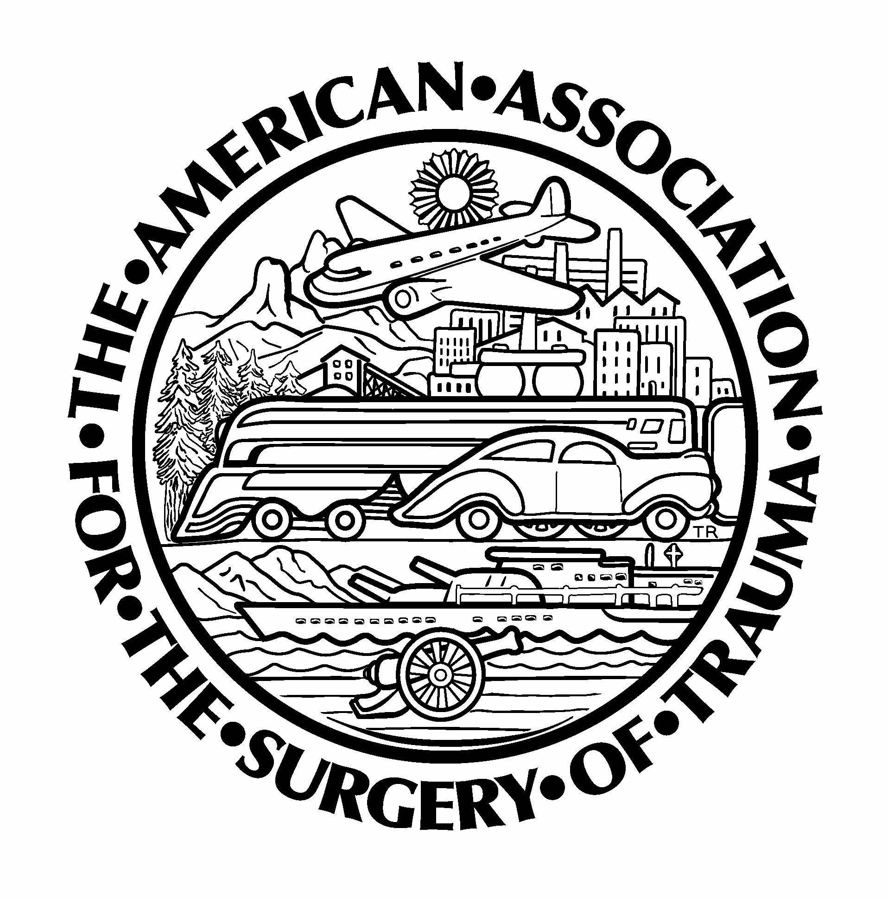
American Association for the Surgery of Trauma

Send the following documents 30 days prior to the site visit:

- Policies and procedures for:
  - fellow duty hours and work environment.
  - recruitment, appointment, eligibility, and selection of fellows.
  - discipline and dismissal of fellows, including due process.
  - supervision of fellows (addressing fellow responsibilities for patient care, progressive responsibilities for patient management, and faculty responsibility for supervision).
- Copy of the fellow contract.
- Current Program Letters of Agreement (PLAs) between the ACS Program Director and subspecialty rotation directors
- Document delineating the skills and competencies the fellow will be able to demonstrate at the conclusion of the program.
- Files of current fellows and most recent program graduates containing the following:
  - Objective assessments of competence in patient care, medical knowledge, practice-based learning and improvement, interpersonal and communication skills, professionalism, and systems-based practice
  - Evaluations showing use of multiple evaluators (faculty, peers, patients, self, and other professional staff).
  - Documentation of fellows’ semiannual evaluations of performance with feedback.
  - Fellows case &/or procedure logs
  - Final (summative) evaluation of fellows, documenting performance during the final period of education and verifying that the fellow has demonstrated sufficient competence to enter practice without direct supervision.
- Documentation of program evaluation and written improvement plan.
- Overall Goals & Objectives & Competency based Goals & Objectives for each training rotation
- Conference schedule & conference attendance records with % attendance by fellow
- Program’s fellow handbook &/or GME policy manual
- Transfer protocols and sample educational materials related to handovers/transfers
- Sample schedules that inform all members of the health care team of attending physicians and residents/fellows currently responsible for each patient’s care.
- Sample documents offering evidence of fellow participation in Quality Improvement and Safety Projects
- Sample documents offering evidence of fellow participation in basic &/or clinical research
- Most recent ACGME Surgical Critical Care review
- Current CVs for all program faculty

